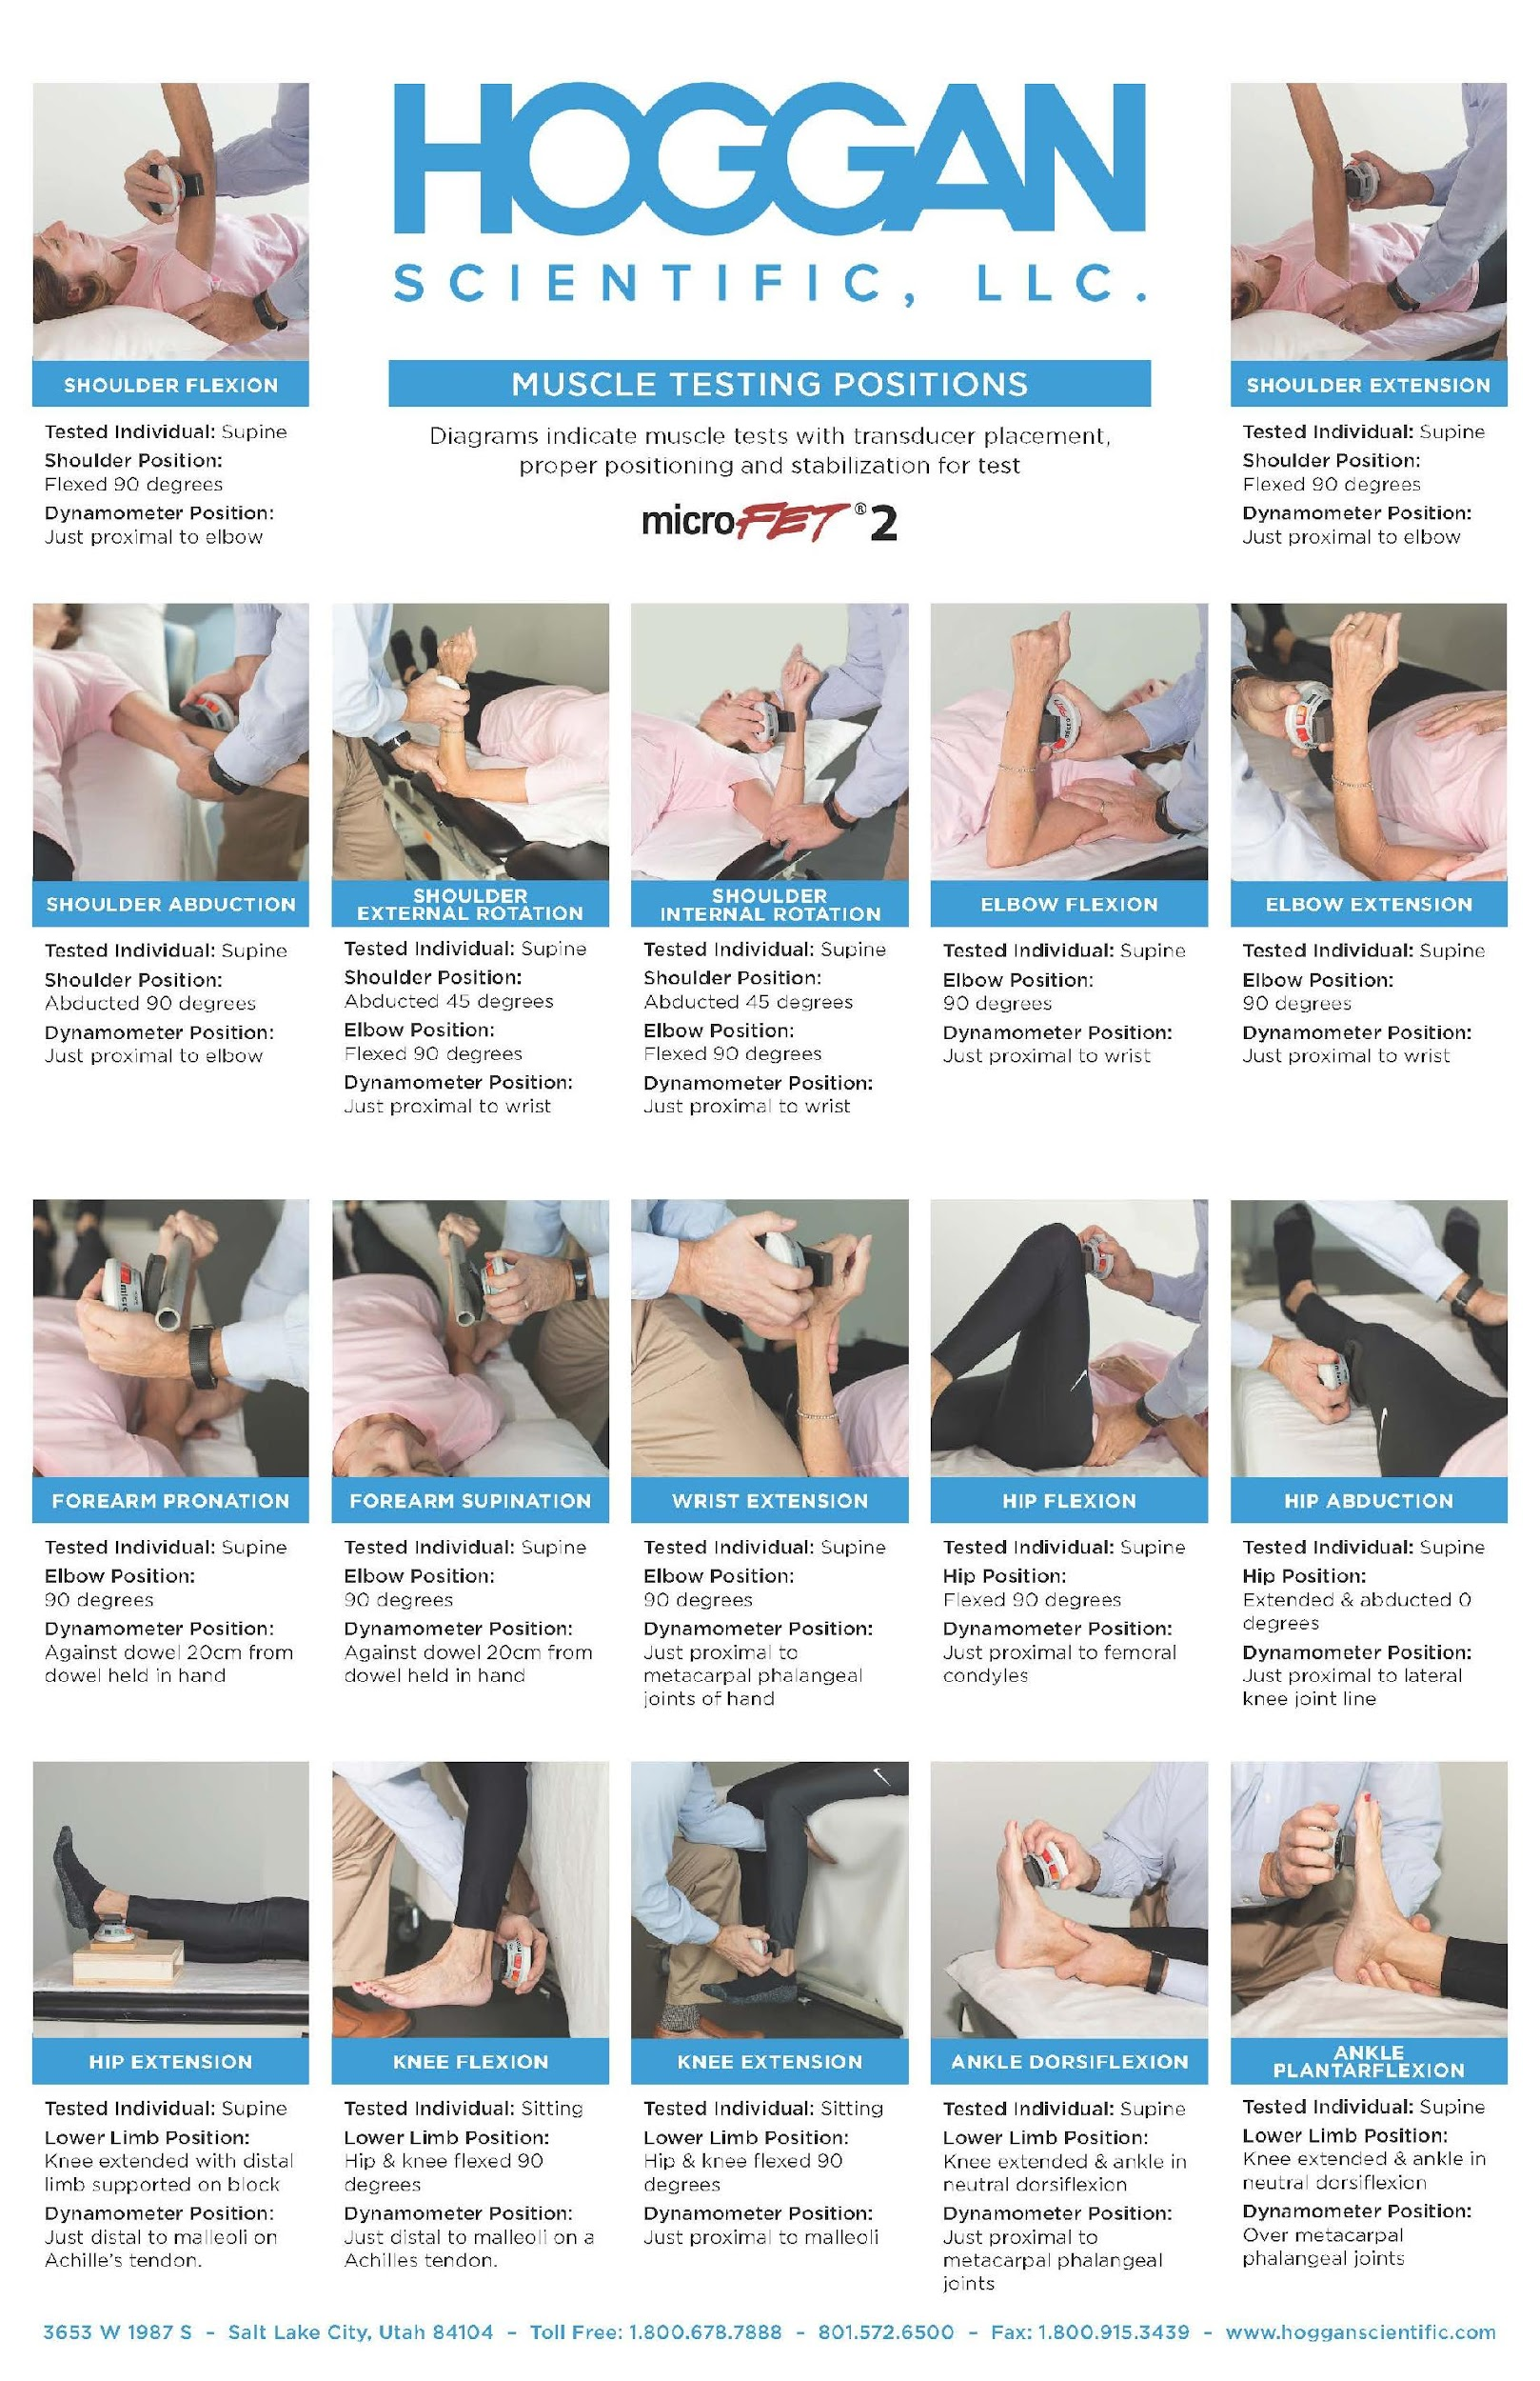
Appendix 1: Procedures for manual muscle testing per Hogan Scientific.

