SUPPLEMENTAL Figure A

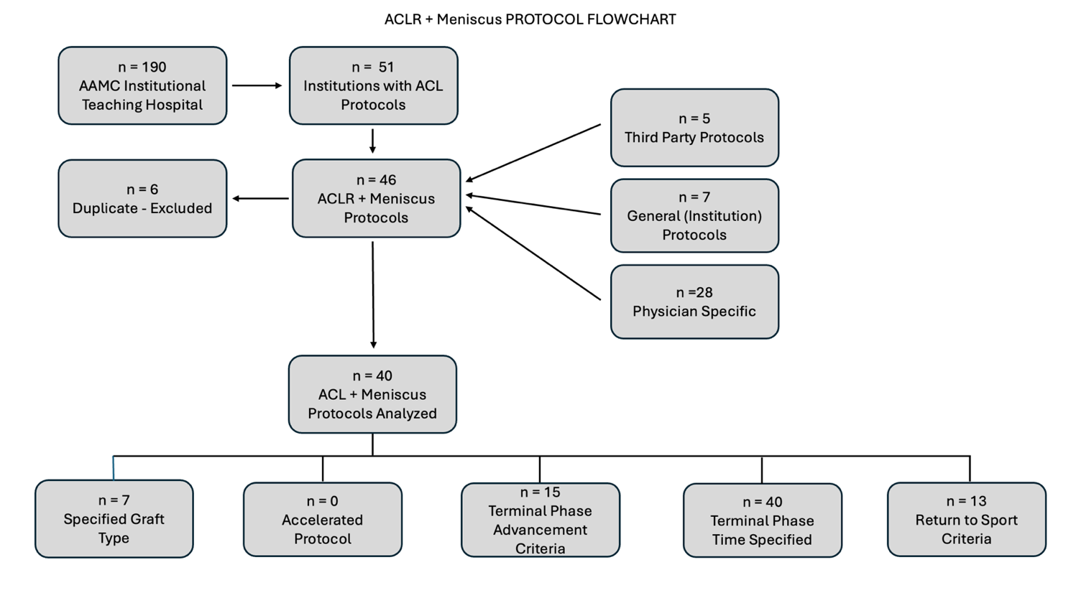
Supplemental Figure A. AAMC = Association of American Medical Colleges, ACL = anterior cruciate ligament, ACLR = anterior cruciate ligament reconstruction

