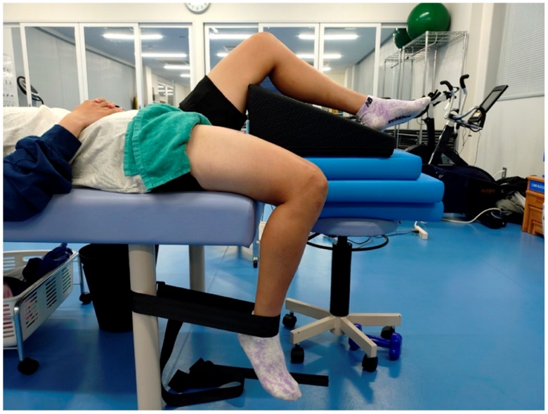
Figure S2: Measurement position for muscle stiffness in the knee-flexed (stretched) position (measurement leg: hip 0°, knee 90°; non-measurement leg: hip 60°, knee 70°).

