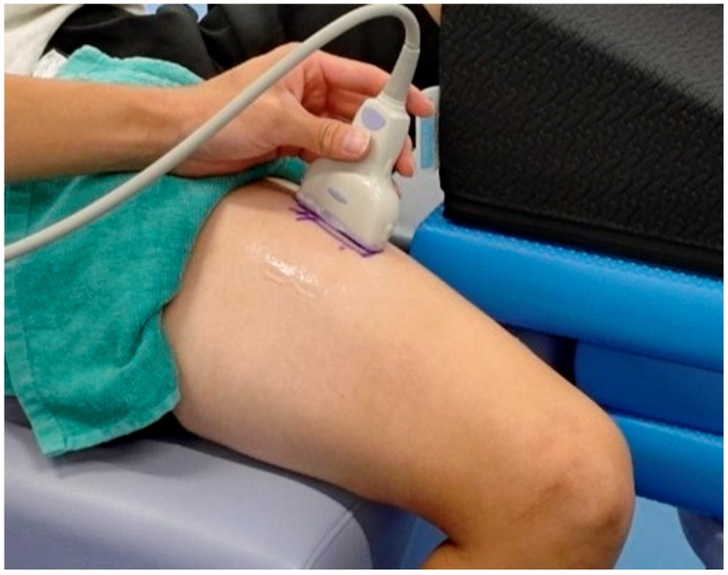
Figure S1: Position of high-frequency linear ultrasound probe for shear wave elastography

