Supplemental File 2: Exercise Program
Exercises performed in order listed
Week 1-2:
- Posterior hip capsule stretch/mobilization 2x1min
- Calf slant board stretch2x1min
- DNS star pattern 3x15
- Kickstand RDLs 3x12
- Leg extension Isometric hold starting at 60 deg and progressing to deeper angles of knee flexion as tolerated 3x60 seconds
Week 3:
- Posterior hip capsule stretch/mobilization 2x1min
- Calf slant board stretch 2x1min
- Couch stretch 2x1min
- DNS star pattern 2x15
- Triplanar proximal resistance loaded SL RDLs⁴² 3x15
- BFR Exercises: 80% occlusion pressure
  - Spanish squats heels elevated 30-degree slant 3x15 BW
  - Slant board step downs 30-degree slant 3x15 BW
  - Eccentric only leg extensions full range 3x15
Week 4:
- Posterior hip capsule stretch/mobilization 2x1min
- Calf slant board stretch 2x1min
- Couch stretch 2x1min
- DNS star pattern 2x15
- Triplanar proximal resistance loaded Step Ups (level 0) with banded TKE 3x15 (Image 1)
- BFR Exercises: 80% occlusion pressure
  - Spanish squats heels elevated 30-degree slant 3x15 BW
  - Slant board step downs 30-degree slant 3x15 BW
  - Eccentric only leg extensions full range 3x15
  - Airdyne bike intervals 20 sec high effort/40 sec easy effort 5 minutes
Week 5:
- Posterior hip capsule stretch/mobilization 2x1min
- Calf slant board stretch2x1min
- Couch stretch 2x1min
- DNS star pattern 2x15
- Triplanar proximal resistance loaded Step Ups (Level 1) with banded TKE 3x15
- BFR Exercises: 80% occlusion pressure
  - Spanish squats heels elevated 30-degree slant 4x15 10# added
  - Slant board step downs 30-degree slant 3x15
  - Eccentric only leg extensions 3x15
  - Airdyne bike intervals 20 sec high effort/40 sec easy effort 5 minutes
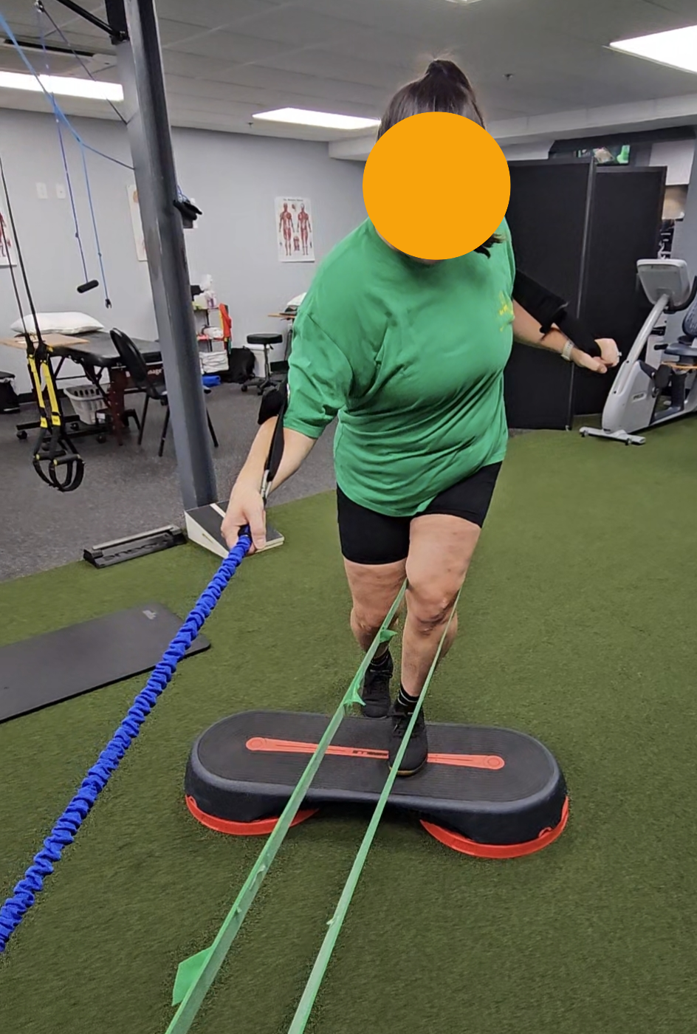
Supplemental Figure 1: Triplanar proximal resistance loaded Step Ups (level 1) with banded TKE

Week 6:
- Posterior hip capsule stretch/mobilization 2x1min
- Calf slant board stretch2x1min
- Couch stretch 2x1min
- DNS star pattern 2x15
- Triplanar proximal resistance loaded Step Ups (level 2) with banded TKE 3x15
- BFR Exercises: 80% occlusion pressure
  - Slant board squats with 3 second isometric pause at bottom 4x10 20#
  - Slant board step downs 30-degree slant 3x15
  - Eccentric only SL leg extensions 3x15
  - Reverse Sled drags 3x1 minute
(BRF discontinued due to load tolerance improvement)
Week 7:
- DNS star pattern 2x15
- Triplanar proximal resistance loaded reverse lunges with counterrotation 3x15
- Heel elevated goblet squats with 3 second isometric pause at bottom 4x10
- Reverse Sled drags 3x 1 minute
- Full SL Leg extensions 3x12
Week 8:
- DNS star pattern 3x15
- Triplanar proximal resistance loaded reverse lunges with counterrotation 3x15
- Heel elevated goblet squats with 3 second isometric pause at bottom 4x10
- Rear foot elevated split squats 3x10
- Full SL Leg extensions 3x12
Week 9-12:
- DNS star pattern 3x15
- Triplanar proximal resistance loaded reverse lunges with counterrotation 3x15
- Banded mini pogo jumps 3x30 seconds
- Heel elevated goblet squats 4x10 (progressing weight as tolerated)
- Rear foot elevated split squats 3x10 (adding weight as tolerated)
- Full SL Leg extensions 3x12
Week 12-14
- DNS star pattern 3x15
- Triplanar proximal resistance loaded reverse lunges with counterrotation 3x15
- Bodyweight mini pogo jumps
  - Progress to pogo x 2 to athletic base stance landing
  - Progress to pogo x2 to split stance landing
- Barbell Front Squats heels elevated 4x10 (progressing weight as tolerated)
- Rear foot elevated split squats 3x10 (adding weight as tolerated)
- Full SL Leg extensions 3x12
Week 14+: Progressive strength and conditioning and plyometrics

