Supplemental File 1: Exercise Images
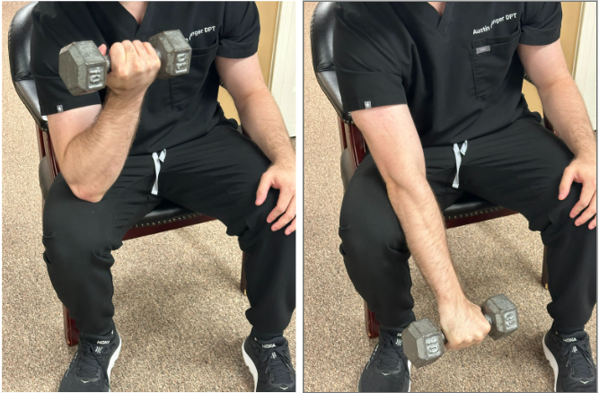
Supplemental Figure 1: Eccentric elbow flexion and supination
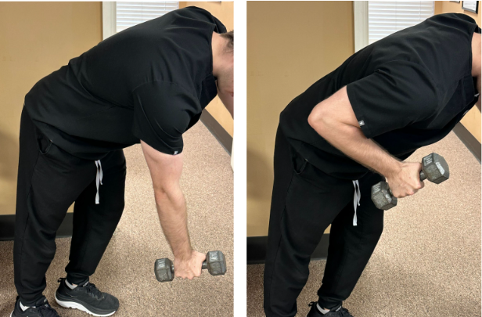
Supplemental Figure 2: Unilateral rows
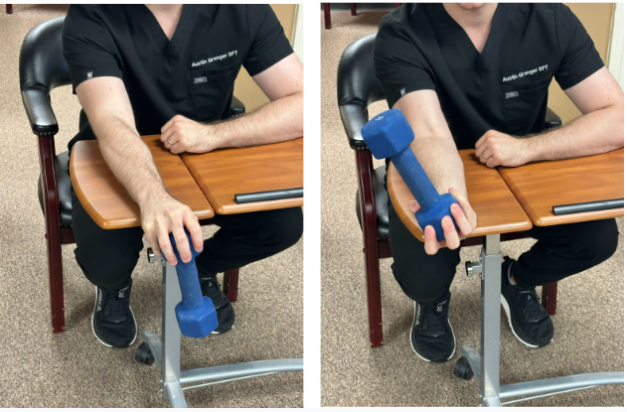
Supplemental Figure 3: Resisted supination

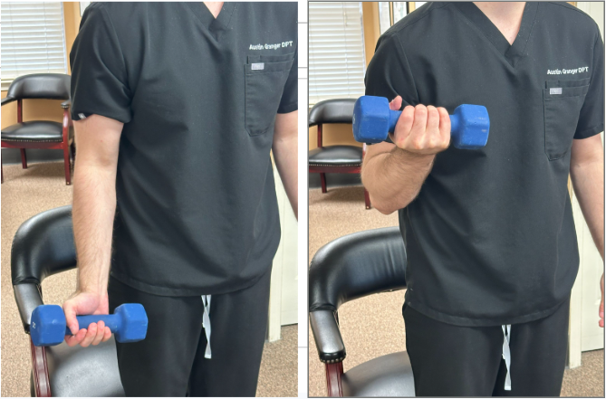
Supplemental Figure 4: Elbow flexion with supinated grip
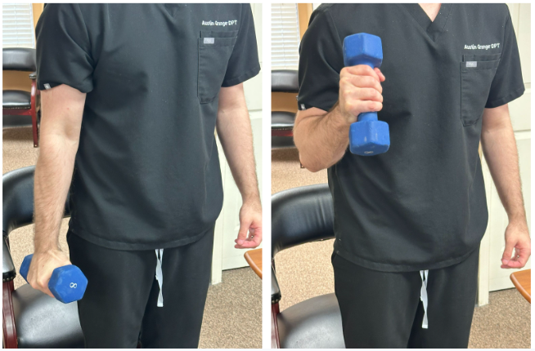
Supplemental Figure 5: Elbow flexion with neutral grip

